EXPERIMENT 7
Procedure to Transfer Files from One Virtual Machine to Another Virtual Machine

Aim
To transfer a file from one Ubuntu virtual environment (VM1) to another Ubuntu virtual environment (VM2) using the SCP (Secure Copy) command.

Prerequisites
- Windows system with WSL 2 and Ubuntu installed.
- Two Ubuntu instances: Ubuntu (VM1) and Ubuntu2 (VM2).
- OpenSSH Server installed and running on VM2.

Procedure

Step 1: Start Ubuntu1
Open Ubuntu1 from Windows CMD using: wsl -d Ubuntu

Step 2: Create a test file
echo "File transferred from VM1" > vm1.txt

Step 3: Verify the file
cat vm1.txt

Step 4: Start Ubuntu2
Open a separate Windows CMD window and run: wsl -d Ubuntu2

Step 5: Start SSH Server
In Ubuntu2, run: sudo service ssh start

Step 6: Check SSH status
Run: sudo service ssh status and confirm Active: active (running).

Step 7: Transfer the file
In Ubuntu1, run: scp vm1.txt administrator@192.168.96.127:/home/administrator/

Step 8: Verify the file
In Ubuntu2, run: cat /home/administrator/vm1.txt

Commands Used
wsl -d Ubuntu
echo "File transferred from VM1" > vm1.txt cat vm1.txt
wsl -d Ubuntu2
sudo service ssh start sudo service ssh status
scp vm1.txt administrator@192.168.96.127:/home/administrator/ cat /home/administrator/vm1.txt

Output
The file vm1.txt was successfully transferred from Ubuntu VM1 to Ubuntu2 using SCP. The received file was verified in Ubuntu2 and displayed: "File transferred from VM1".
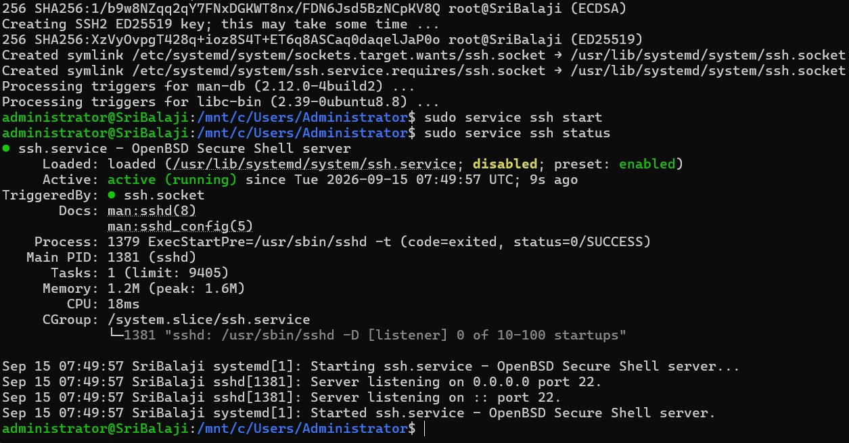

Figure 1: SSH server running successfully in Ubuntu2
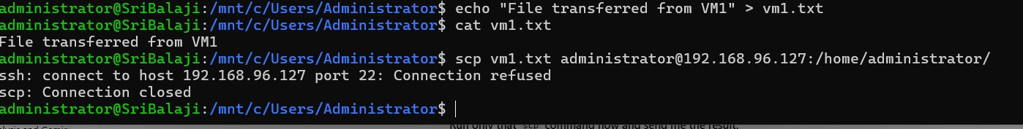

Figure 2: SCP file transfer completed successfully
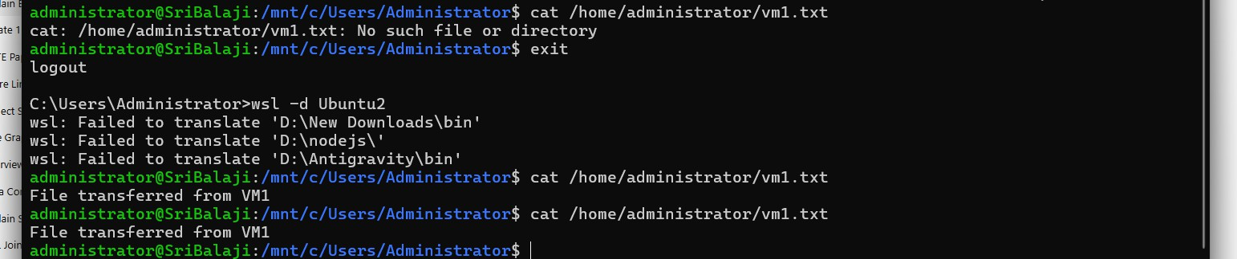

Result
Figure 3: Transferred file verified in Ubuntu2

Thus, the file vm1.txt was successfully transferred from one Ubuntu virtual environment (VM1) to another Ubuntu virtual environment (VM2) using the SCP command and the transferred file was verified successfully.

